<https://github.com/YanHaoChen/Learning-SDN/tree/master/Controller/Ryu/Install>

<https://blog.csdn.net/cyz14/article/details/79994548> <- ‘tinyrpc’ distribution was not found

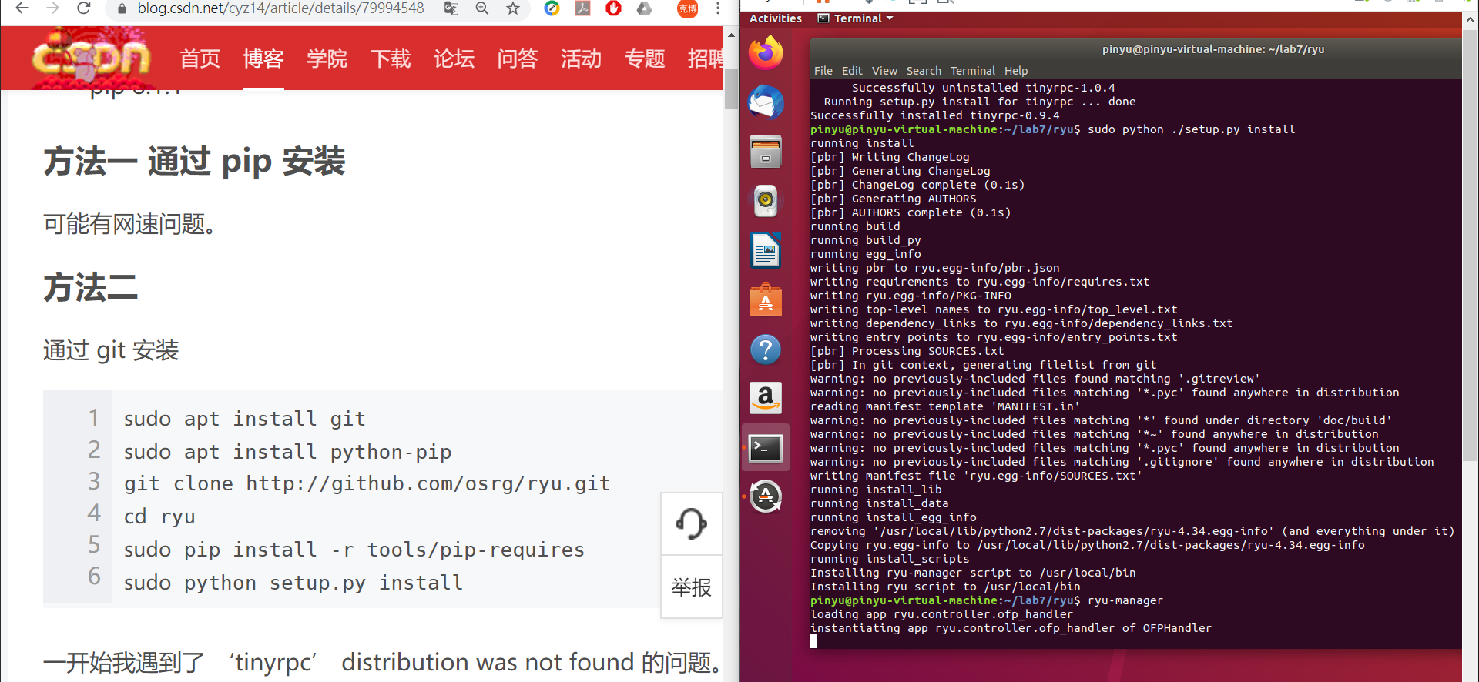

[步驟]

$ sudo apt-get update //更新可取得的套件版本

$ sudo apt-get install python-pip //安裝 pyhon 套件管理器 pip

$ sudo apt-get install git

sudo pip install -r ./requirement.txt

requirement.txt

greenlet>=0.4.15

oslo.config>=6.11.1

msgpack>=0.6.2

eventlet>=0.18.2

Routes>=2.4.1

WebOb>=1.8.5

paramiko>=2.6.0

tinyrpc>=1.0.3

ovs>=2.11.0

git clone git://github.com/osrg/ryu.git

cd ryu

sudo pip install -r tools/pip-requires

sudo python setup.py install

ryu-manager